

**Project Report**

**on**

**­­­­E -Commerce**

Submitted to

**LOVELY PROFESSIONAL UNIVERSITY**

for

**Bachelor of Computer Science and Engineering**

**Submitted By Submitted to**

**Ashraf Zeya Dr. Allam Mohan**

**11905686 27289**

**LOVELY FACULTY OF TECHNOLOGY & SCIENCES**

**LOVELY PROFESSIONAL UNIVERSITY**

**PUNJAB**

**October 2022**

**Table of Contents**

**Chapter Particulars Page No.**

1. Introduction……………………………………………………… 03
2. Technologies used…………………………………………………04-05
3. Modules……………………………………………………….........06
4. Website snapshots…………………………………………………07-08
5. GitHub link link………………………...................................................09

**CHAPTER 1**

**INTRODUCTION**

1. An e-commerce website is one that allows people to buy and sell physical goods, services, and digital products over the internet rather than at a brick-and-mortar location. Through an e-commerce website, a business can process orders, accept payments, manage shipping and logistics, and provide customer service.
2. Frontend Technologies- HTML, CSS
3. Backend Technologies- JavaScript, Node.js
4. Used Socket.io module for a two-way connection between client and server.
5. Frontend includes a navigation bar, sign in and sign up of e-commerce website.
6. HTML has been used for preparing the structure of application.
7. CSS has been used for styling the application.
8. Added Client sided JavaScript for the purpose of playing with DOM elements.
9. Every time a new user tries to join, first of all ask his/her name and let the server know.
10. If a new user joins, receive the event from the server using event Listener.
11. Receive message from server using receive function.
12. If a user leaves the chat, tell all the other users that this user has left the chat.
13. Server Side JavaScript will handle the Socket IO connections.
14. If a new user joins, it will let the other users connected with server know.
15. If someone sends the message, it will broadcast it to other people.
16. If someone leaves the chat, the application will let others know.

**2. Technology Used**

In this project I have used-

1. **Html** – The Hypertext Markup Language, or HTML is the standard markup language for documents designed to be displayed in a web browser. For all the structure that are present in the web application. Like all the buttons and textbox, text areas etc. HTML is the standard markup language for Web pages.
2. Icon

   Description automatically generated**CSS** – I have used CSS for to define styles for your web pages, including the design, layout and variations in display for different devices and screen sizes. It is easier to make the web pages presentable using CSS. CSS helps us to control the text color, font style, the spacing between paragraphs, sizing of columns, layout designs, and many more. It is independent of HTML, and we can use it with any XML-based markup language.
3. Logo

   Description automatically generated**JavaScript –** JavaScript is a text-based programming language used both on the client-side and server-side that allows you to make web pages interactive. Where HTML and CSS are languages that give structure and style to web pages, JavaScript gives web pages interactive elements that engage a user.

JavaScript is used to give the meaning for the project. JavaScript is the most important thing we can add to our web application

1. **Node-** Node.js is a server-side platform built on Google Chrome's JavaScript Engine (V8 Engine). Node.js was developed by Ryan Dahl in 2009 and its latest version is v0.10.36. The definition of Node.js as supplied by its official documentation is as follows −

Node.js is a platform built on Chrome's JavaScript runtime for easily building fast and scalable network applications. Node.js uses an event-driven, non-blocking I/O model that makes it lightweight and efficient, perfect for data-intensive real-time applications that run across distributed devices.

1. **Socket I/0 –** Itis a JavaScript library for Realtime [web applications](https://en.wikipedia.org/wiki/Web_application). It enables Realtime, bi-directional communication between web clients and servers. It has two parts: a [client-side](https://en.wikipedia.org/wiki/Client-side) library that runs in the [browser](https://en.wikipedia.org/wiki/Web_browser), and a server-side library for [Node.js](https://en.wikipedia.org/wiki/Node.js). Both components have a nearly identical [API](https://en.wikipedia.org/wiki/Application_programming_interface). Like [Node.js](https://en.wikipedia.org/wiki/Node.js), it is event driven. Socket.IO primarily uses the WebSocket protocol with polling as a fallback option,[3][4] while providing the same interface. Although it can be used as simply a wrapper for WebSocket, it provides many more features, including broadcasting to multiple sockets, storing data associated with each client, and asynchronous I/O.

**3. Module –** In this project I have only single component that is single page. That page contains of multiple section like Header , Footer , and the main display area . All the modules are explained below

**3.**1- Header – In this the simplest area where we haven't done anything we have just insert inserted logo of our web application. and given the name of the web application we have done a simple CSS and basic HTML in that section.

**3.2** – Display Area - This is the most important section of our application in this section we can see all the activities which we are doing. like we can see all the text which we are chatting with our friend. In this section we can see the name of our friend with whom we are chatting. The text which the user has written will display on the left side and the text or message which the user has received from his friend side will display on the right side. All these messages will display in a box so that there are no chances of mixing all the tests and confusion.

This section will also display whenever a friend has joined the chat it will simply show the message that the ‘xyz’ has joined the chat.

**3.3- Footer -** this is also important section off over application. This section consist of a text area and a send button. we can write all the messages guess we want to send to a friend in the text area and simply click on the send button to send the message. the text area accept all kinds of text including character numeric value symbols etc.

**4. Web app Snap shot –**

**1.sign in your account**

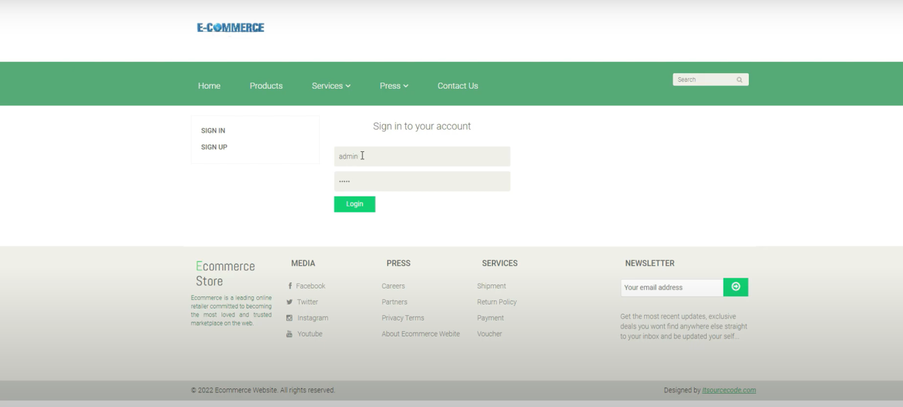

**2.Home page**

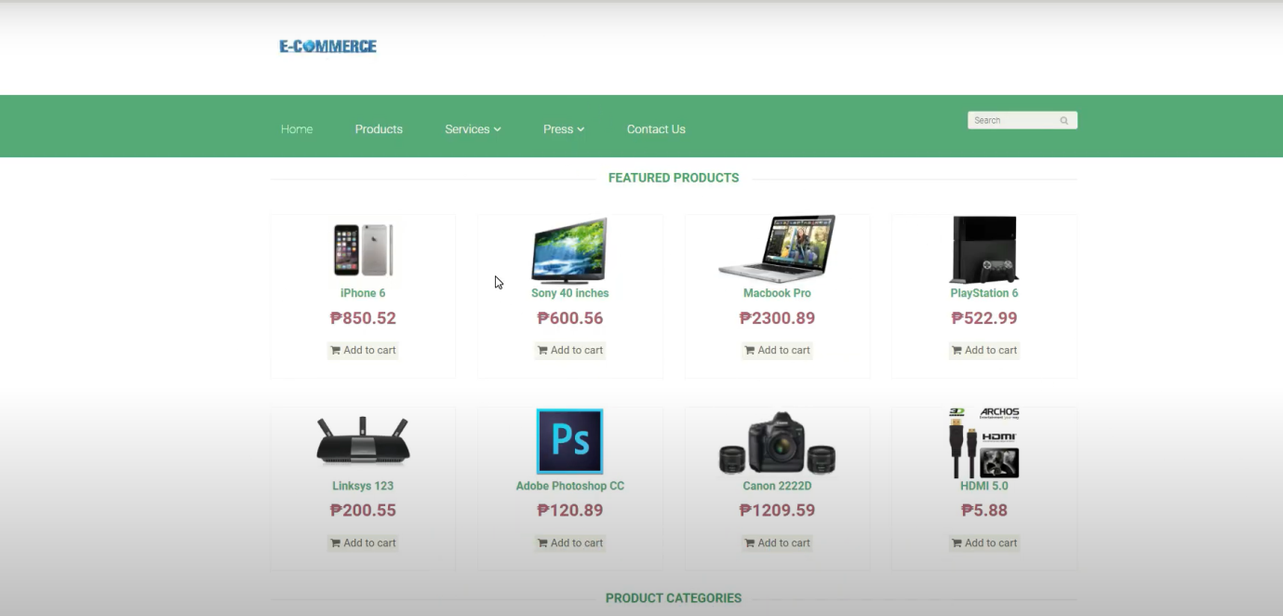



**Chatting between different user**



**4. GitHub link -** [**https://github.com/lrbkml/Chat-Applicatiion.git**](https://github.com/lrbkml/Chat-Applicatiion.git)